**Minification In Windows10 using YUI-Compresser and Linux Shell Script**

**Prashik@Agile**

**Enable Ubuntu in Windows10:**

**a)**

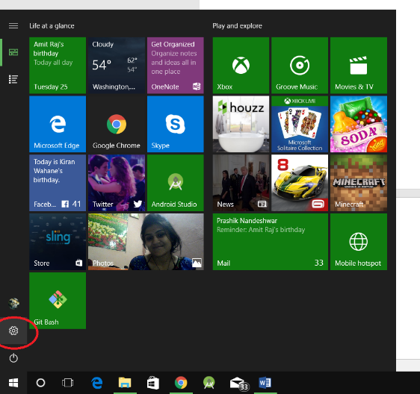

**b)**

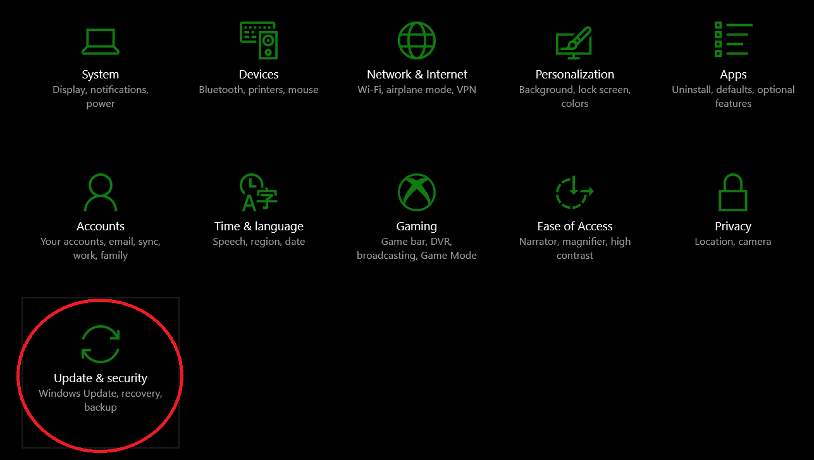

**c)**

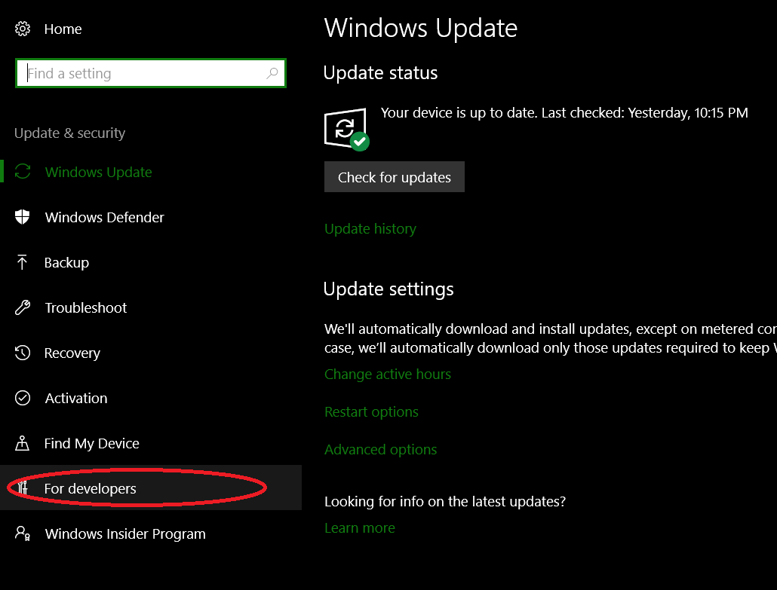

**d)**

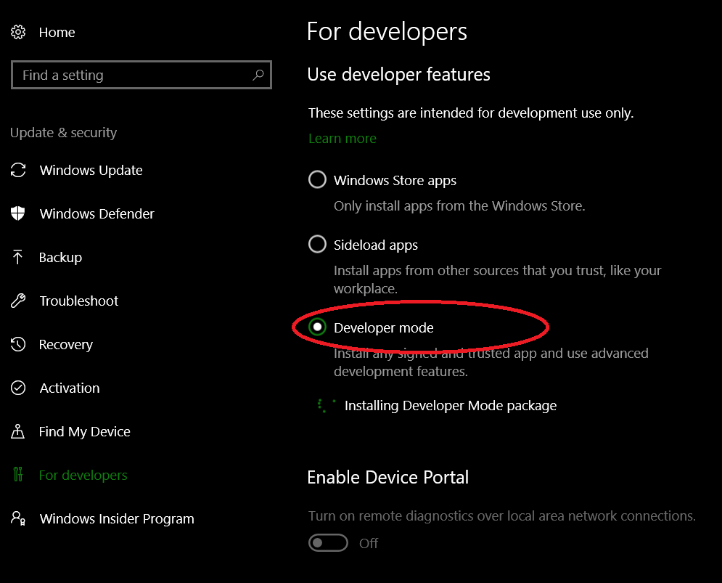

**e)**

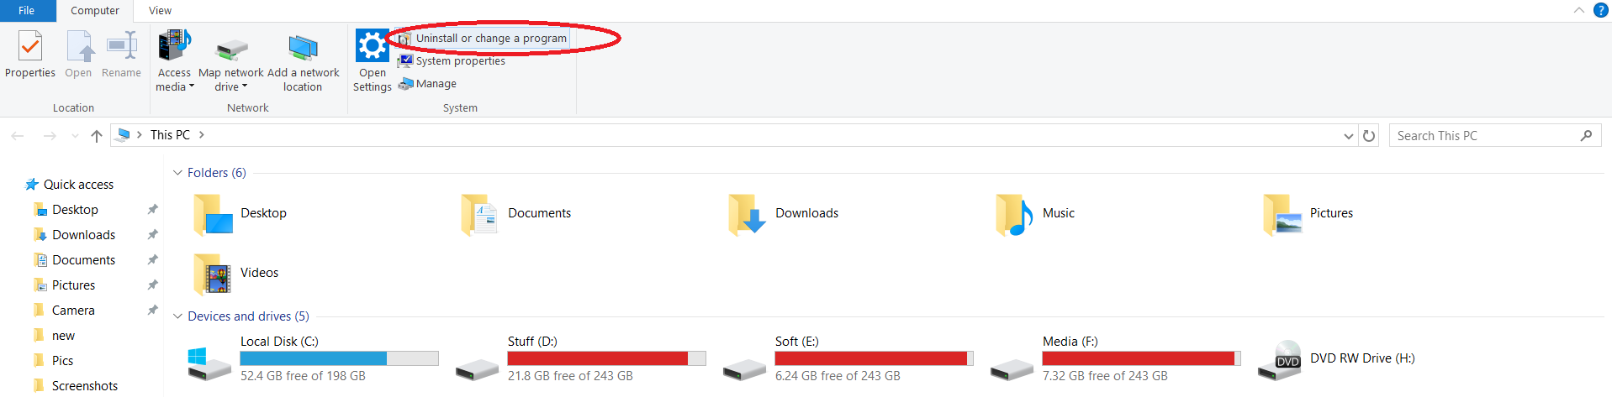

**f)**

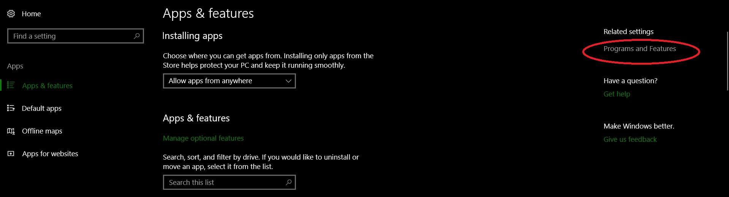

**g)**

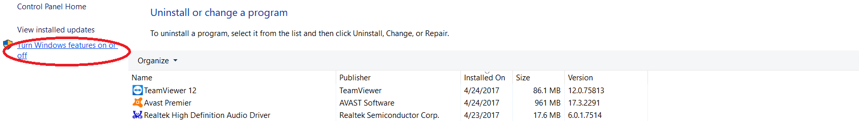

**h)**

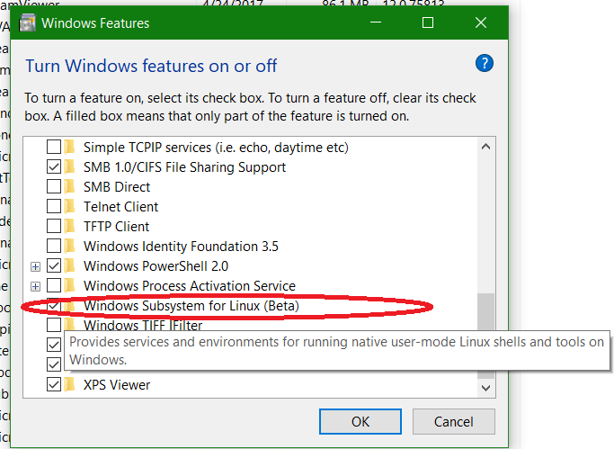

**i)**

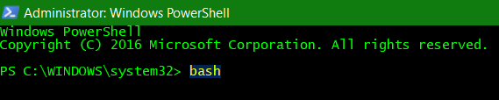

**Install JRE:**

**a) Run Powershell / CMD as Administrator and Exit Antivirus until JRE installation(Firewall blocks internet connectivity in Ubuntu)**

C:\Users\Prashik\AppData\Local\Microsoft\Windows\INetCache\Content.Word\Screenshot (21).png

**b)**

C:\Users\Prashik\AppData\Local\Microsoft\Windows\INetCache\Content.Word\Screenshot (22).png

**Run Minification shell script:**

**a)**

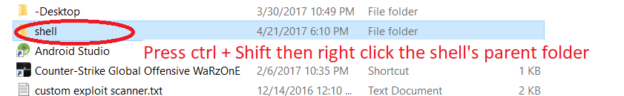

**b)**

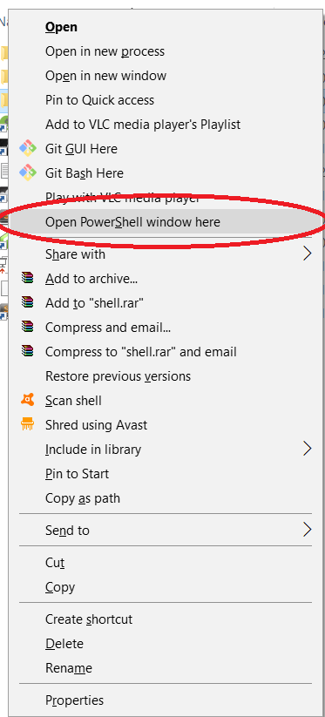

**c)**

C:\Users\Prashik\AppData\Local\Microsoft\Windows\INetCache\Content.Word\Screenshot (24).png

**d)**

C:\Users\Prashik\AppData\Local\Microsoft\Windows\INetCache\Content.Word\Screenshot (25).png

**e)**



**f)**

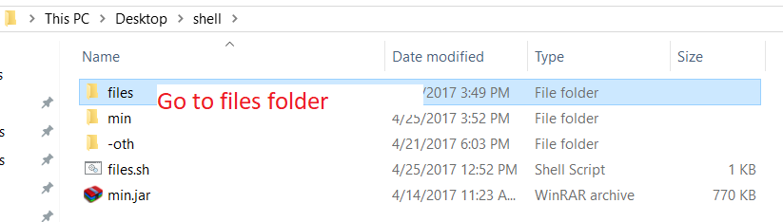

**g)**

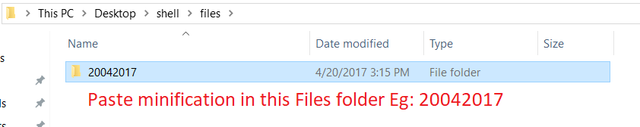

**h)**



**i)**

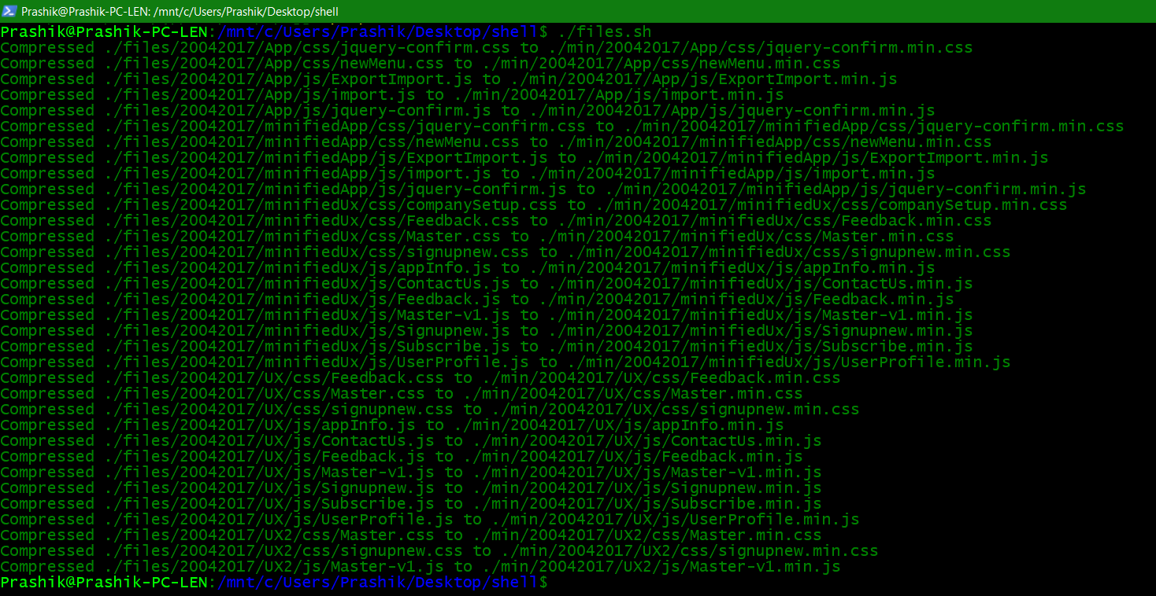

**j)**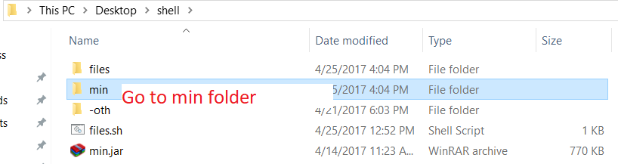

**k)**



**l)**

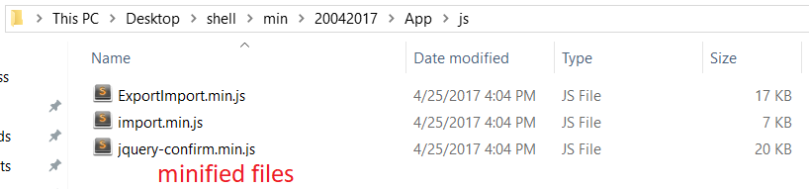

**SUCCESS 😊**